What is a Linked List?

Is a form of sequential collection and it does mot have to be in order. A linked list is made up of independent nodes that may contain any type of data each node has a reference to the next node in the link. Like a train 😊

In linked list we have head and tail.

It contains two parts: linking part and values. And nodes are linked to each other.

We need a head because we need to know from where it starts. The last is tail which tell about last node. And we can increase the efficiency of linked list.

What is the difference between linked list and an Array?

In linked list, each element are independent objects. We can delete any node , but we cannot delete a cell.

In Linked list we do not need to define a size but in array is. But in Array we need to define and wjen we reach the capacity we cannot add.

Accessing element in Array is very efficient because of indexing, but in linked list we need to iterate the list and start from the head.

Different types of linked lists?

1. Singly Linked List

Each node in the list, stores the value and reference to the next node, not have a reference to the previous node. From second node we cannot go to the first node. We only store physical location of next node. The last node Is null.

1. Circular singly Linked List

It is the same as singly Linked List, but the last node references to the first node, when we reach the last node of linked list, we have an option of going back to the first node, which is not possible in case of singly linked list. Last node always points to the first node.

1. Doubly Linked List

in this type is we have references to next list and previous node. Like a music application 😊

1. Circular Doubly Linked List

In first node we have previous reference to the last node and in the last node we have next reference to the first node. it creates a circle.

How Linked List stores in memory?

It does not store contiguously. In linked list each node needs an extra space for the linkers.

We do not know the location of each node. We cannot directly access each node.

There are 3 ways to insert into a linked list in Memory:

1. At the beginning of the linked list

Allocating a random memory in the heap for the node and we assign the address to the head.

1. After a node in the middle of linked list

We need to traverse a head to put it in the middle and we need to assign the new pointer.

1. At the end of the linked list

We need to traverse the element till the last element.

What is traversal of singly Linked list?

We are visiting each node one by one, until the end of the singly linked list.

How to find a value in a linked list?

Here we need to traverse the whole linked list.

How to delete a value in a linked list?

1. Deleting the first node
2. Deleting any given node
3. Deleting the last node

How to delete the entire singly linked list?

We need to disconnect the header and tail. And garbage collector deletes from the memory.

What is the time complexity in Simply Linked List?

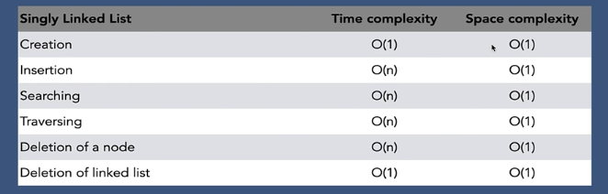

What is the time complexity in circular Simply Linked List?

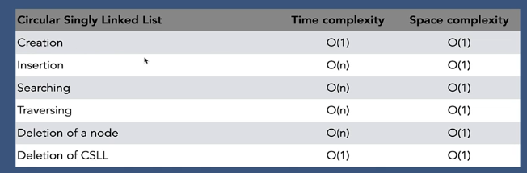

What is the time complexity in Double Linked List?

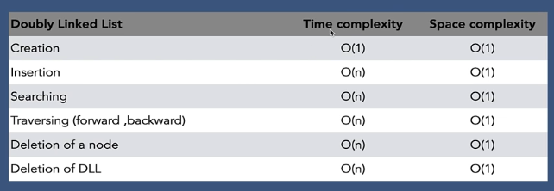

Time complexity of Array vs Linked List

